**PARADOX CHARTER**

# **Table of Contents**

**Table of Contents**

**A. What is Paradox**

Overview

Vision & Mission

1. Organizational Structure

i. Organization Hierarchy

ii. Event Team Hierarchy

2. Departments

3. Paradox Calendar

**B. Recruitment and Ladder to the Top**

1. Eligibility

2. Promotion

**C. Roles & Responsibilities**

1. Roles

2. Responsibilities

**D. Grievance Redressal**

1. Escalation Matrix

**E. Guidelines**

1. SOP (Standard Operating Procedures)

All Students

Paradox Team

Event Team

Houses and Societies

Event Selection:

2. Impeachment

3. Code of Conduct

**F. Repercussions**

**G. Charter’s Amendment Process**

# **What is Paradox**

## **Overview**

Held annually at the IIT Madras Campus, Paradox is a four-day event organized by IIT Madras BS Degree. Presented as an annual student run fest, this unique fest is only open to BS degree students. Its goal is to bring the BS community together and give them a true experience of college life. Cultivating an environment that is stimulating and encourages learning, teamwork, and amusement, Paradox celebrates diversity, creativity, and innovation. Aside from the thrill of the different activities, attendees can anticipate special encounters, chances for networking, and treasured moments, which makes Paradox a crucial and remarkable component of the BS degree path.

## **Vision & Mission**

**Vision:** Our vision is to create an immersive fest experience that cultivates vibrant campus life and fosters deep networking among students. By leveraging the diverse student community, we aim to offer unparalleled opportunities for educational engagements and significant peer connections, distinguishing Paradox as a unique and enriching event.

**Mission:** Our mission is to nurture talent, promote creativity, and facilitate invaluable networking opportunities within the Paradox community. We prioritize inclusivity by hosting a diverse range of Technical, sporting and cultural activities that enhance the campus environment and foster a sense of belonging. Through curated seminars, workshops, career-focused events, and cultural performances, we empower participants to actively engage, learn, and grow. Our efforts are guided by continuous feedback, ensuring our events remain relevant, impactful, and aligned with our long-term vision for Paradox.

## **Organizational Structure**

Students work together with the direction of Secretaries who are propelled by the Steering Committee. The hierarchical structure of the organization guarantees efficient planning and implementation, with several departments responsible for managing the different aspects of the fest's operations and logistics.

#### **i. Organization Hierarchy**

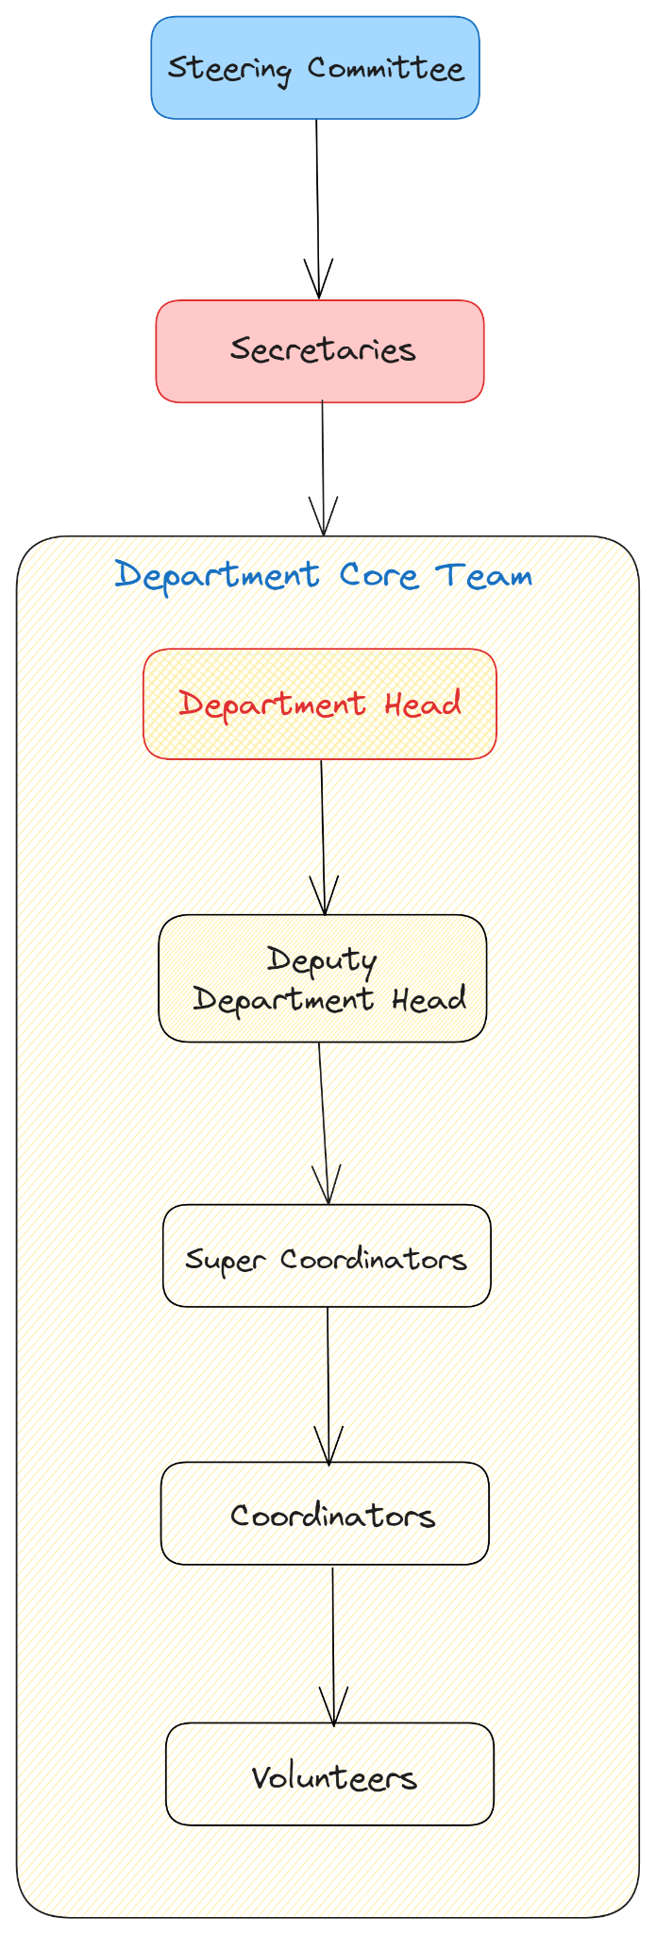

#### **ii. Event Team Hierarchy**

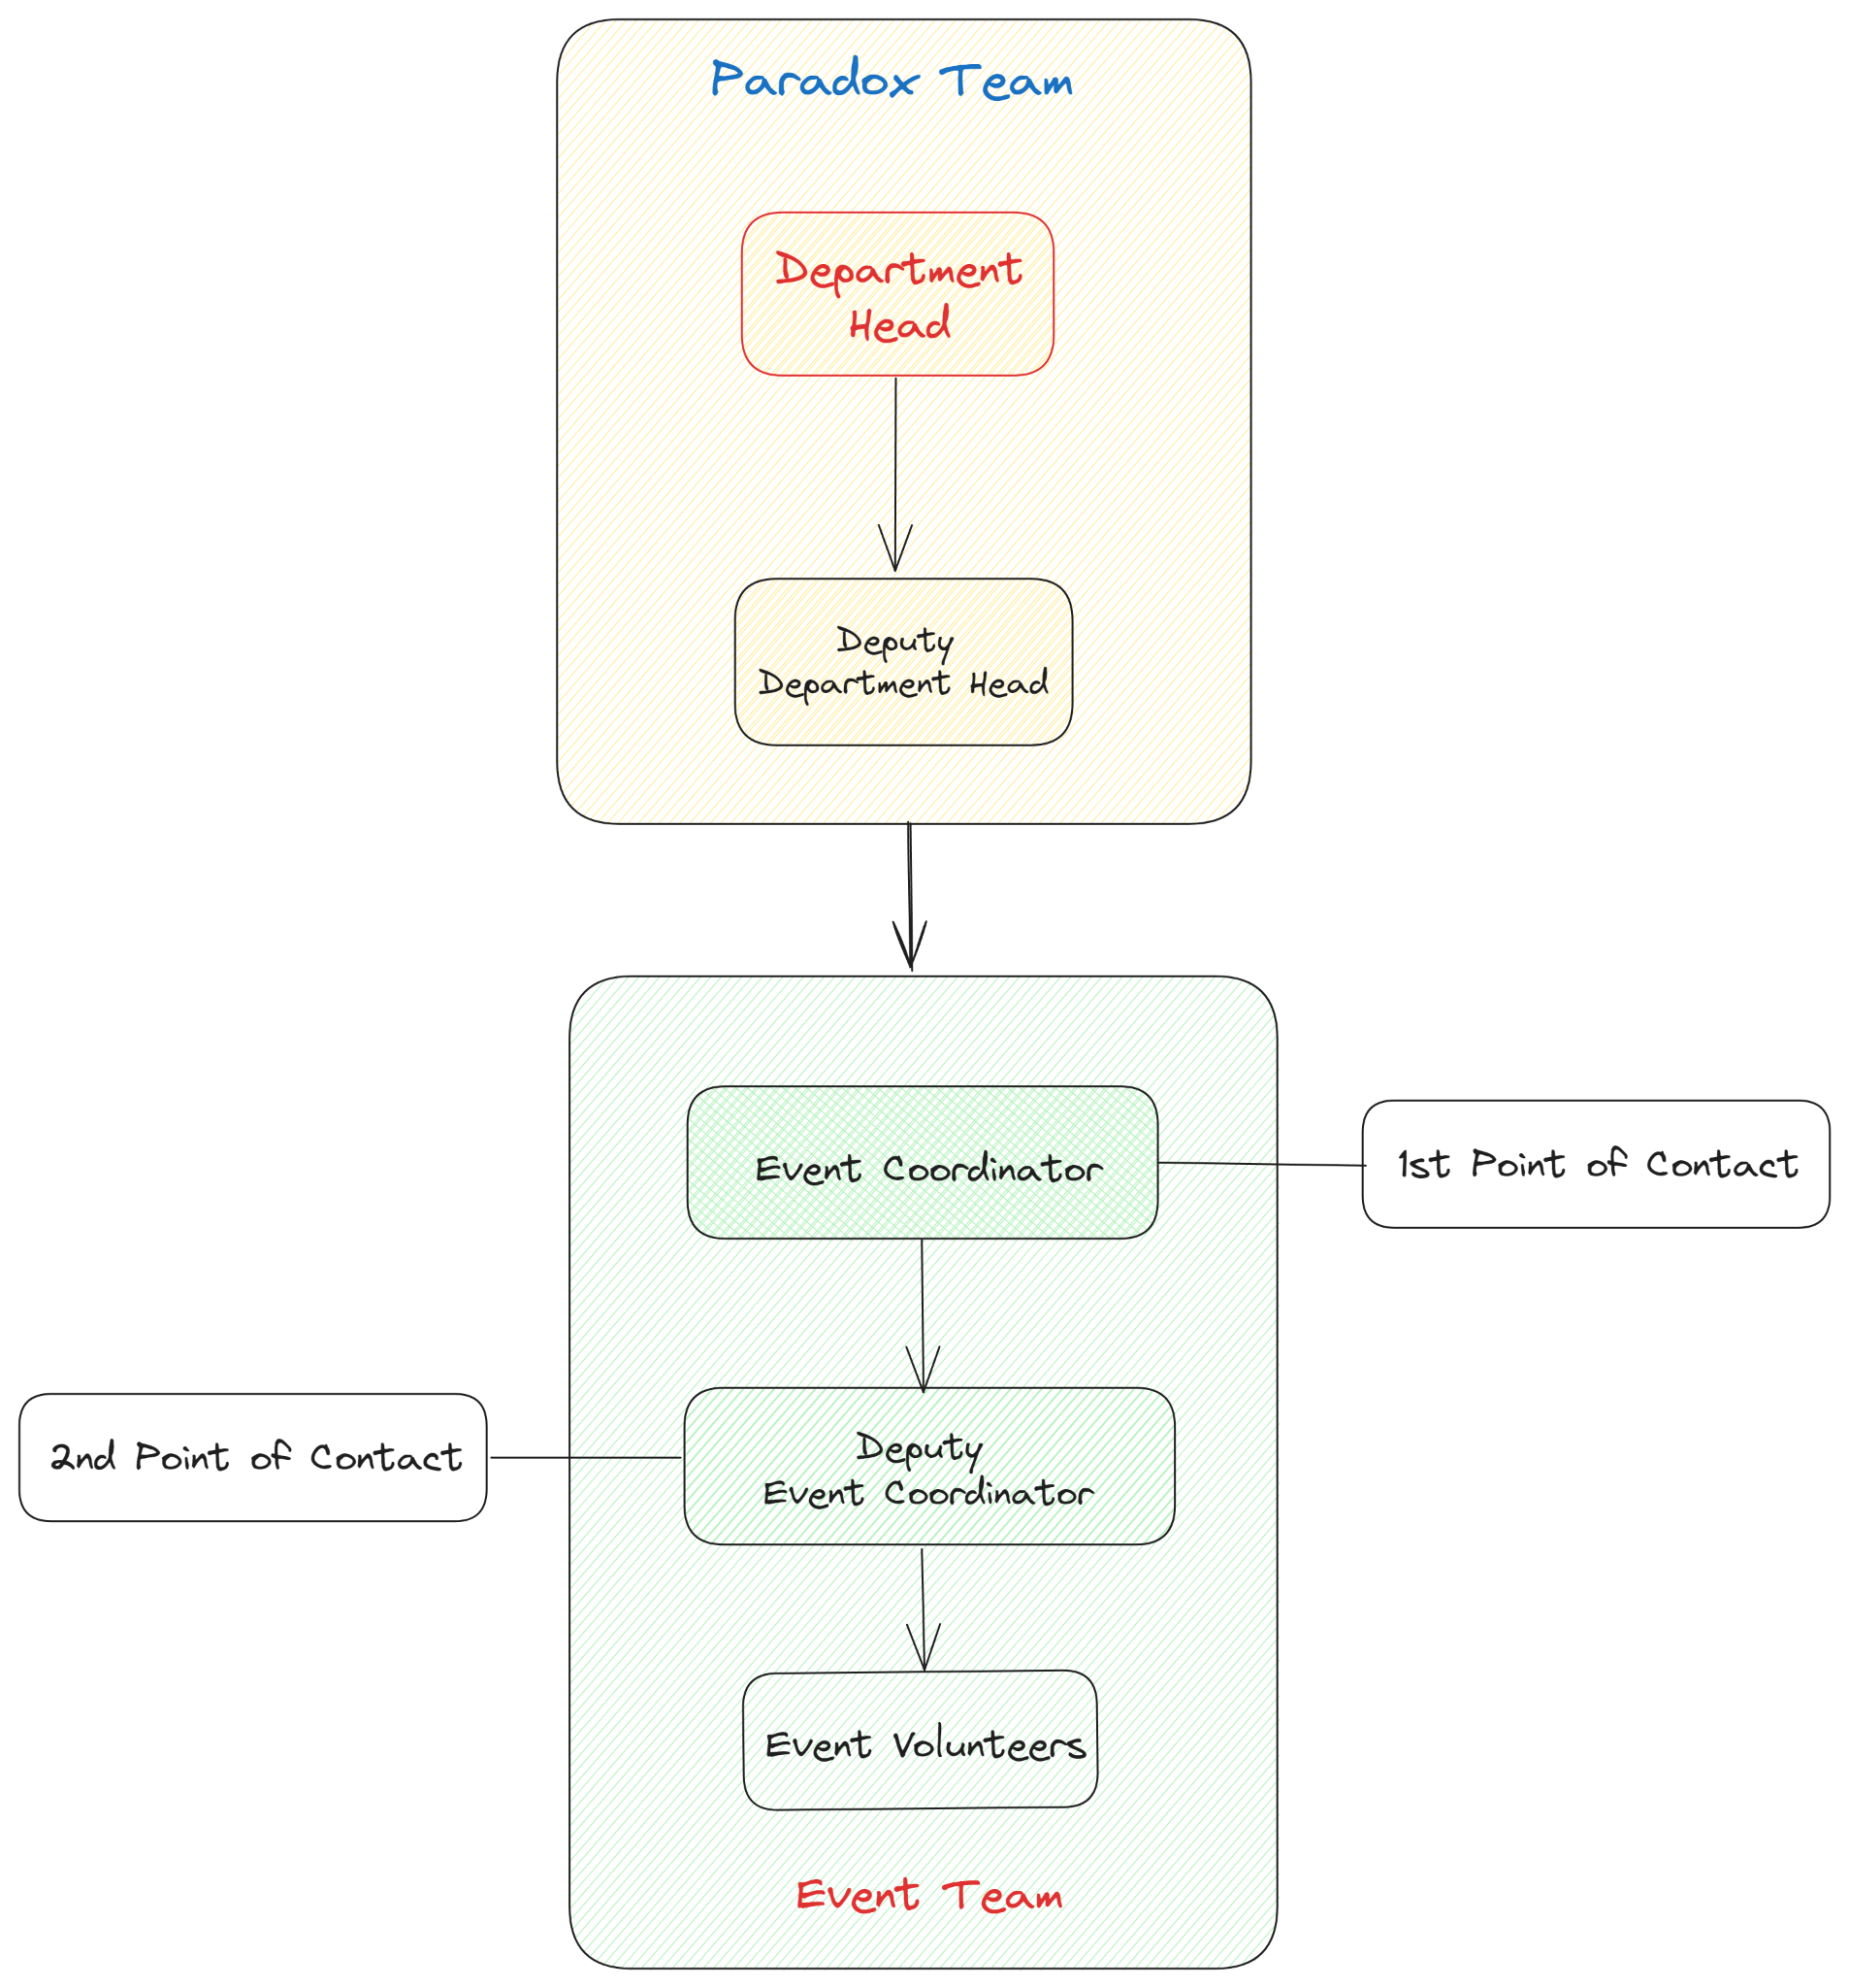

## **Departments**

* Technicals
* Culturals
* Sports
* Sponsorship
* Multimedia Productions
* Student Relation (SR)
* Safety & Security
* WebOps
* Finance and Operations
* Hospitality Relations

## **Paradox Calendar**

Paradox, our vibrant festival, unfolds across three distinct installments throughout the academic year, each offering its unique blend of excitement and engagement.

First up is **Saavan**, an exciting event that takes place in September during our term break. With a dynamic combination of online events and activities that attract participants and feed their passions, this episode sets the tone for the upcoming year.

After Saavan, we jump into **Margazhi**, which is named after the Tamil month and highlights our December term break. Margazhi is a culturally vibrant platform that celebrates creativity and diversity via a wide range of online experiences that uplift the soul and spirit.

Lastly, during the final week of May, Offline **Paradox** takes front stage, turning our campus into a center of excitement and activity. Offline Paradox provides a tangible, immersive experience, in contrast to its virtual counterparts, bringing participants together for four days of incomparable in-person connection, exploration, and celebration.

With engaging events and insightful workshops, Offline Paradox offers a once-in-a-lifetime experience where friendships are formed, skills are displayed, and lifelong memories are created. Prepare to enjoy Paradox's charm as we set out on this thrilling journey together.

# **Recruitment and Ladder to the Top**

## **Eligibility**

To be eligible to participate in the organizing team, students must meet the following criteria:

1. Preferable minimum CGPA of 7
2. Should not have any record of Malpractice against IITM BS Code of Conduct.
3. Should not hold any other Position of Responsibility (POR) in the degree.
4. The age limit to be an organizer in paradox is 25 or below. Exceptions are allowed after the steering committee’s approval.
5. In addition to being available for offline participation at the IIT Madras Campus if necessary (with at least two months' notice), prospective applicants must commit to spending 21 hours a week working for the fest(online). Candidates should be ready to participate in frequent meetings and calls, training sessions, and fest-related activities in addition to this commitment before, during, and after the fest.

## **Promotion**

1. It is necessary to successfully complete a full term in the current designation in order to be eligible for promotion.
2. Candidates must carry out all duties related to their present position, diligently.
3. It is a competitive process, so applying for a promotion does not ensure that you will be chosen.
4. The following is the organizational hierarchy for promotions:
   1. Steering Committee
   2. Secretary
   3. Head & Deputy Head (Core team)
   4. Super Coordinator
   5. Coordinator
   6. Volunteer
5. Individuals can apply for promotion in the upcoming tenure of Paradox.
6. First round of the selection process will be through shortlisting google form responses, followed by an interview round.
7. Promotional selection is contingent upon the interview procedure, which guarantees that selected individuals continually exhibit commitment and aptitude.
8. The steering committee and secretaries have the final say in promotions, and they have the authority to disregard point 2A.

# **Roles & Responsibilities**

The following section will give a concise overview of the responsibilities and expectations for each position within Paradox.

## **1. Roles**

**1.Steering Committee:**

The Steering Committee, composed of previous year’s Secretaries and distinguished contributors from past editions, is appointed by the Head of Student Affairs. These eminent members bring diverse backgrounds and unwavering dedication to ensuring the success of Paradox. They serve as mentors to the Secretaries, imparting a wealth of knowledge and commitment to the committee.

The Steering Committee wields veto power over all decisions made by the Secretaries and is responsible for appointing the Secretaries in close consultation with the Head of Student Affairs and previous Steering Committee members. The criteria for Secretary appointments will be released prior to the recruitment process. Additionally, the Steering Committee plays a crucial role in the appointment of Heads and Deputy Heads of departments, working in conjunction with the Secretaries to ensure the selection of the most qualified candidates. The Steering Committee ensures that the Secretaries always adhere to the established guidelines and follow the charter, maintaining the integrity and vision of Paradox throughout their tenure.

**2.Secretaries:**

All the Secretaries were Department Cores in the previous Paradox, showcasing their dedication and exceptional organizational skills. Their long-standing affiliation with Paradox signifies their unwavering commitment to the festival's expansion and prosperity. These Secretaries spearhead the festival under the able guidance of the Steering Committee members, who oversee their activities and provide strategic direction. While the Secretaries hold a powerful and influential role in driving the festival's success, they remain accountable to the Steering Committee, ensuring their actions align with the broader vision and objectives of Paradox.

**3.Department Head:**

The Department Head, known as the Core, serves as the leader and primary point of contact for the department, responsible for making final decisions, setting goals, overseeing activities and projects, managing resources, providing guidance to Supercoordinators, and representing the department to stakeholders. Candidates must have prior experience as a Supercoordinator in Paradox, unless exempted by the Secretaries.

**4.Deputy Department Head:**

The Deputy Department Head, also referred to as the Deputy Core, functions as the second point of contact for the department, working closely with the Department Head to assist in all responsibilities. They support decision-making, goal-setting, activity oversight, resource management, guidance provision to Supercoordinators, and representation of the department. Similar to the Department Head, candidates for this role must have prior experience as a Supercoordinator in Paradox, unless exempted by the Secretaries.

**5.Super Coordinator:**

As the leader of a specific domain within the department, the Supercoordinator is tasked with developing and implementing strategies, managing activities, supervising Coordinators and Volunteers, providing regular updates to the Core, and collaborating with other Supercoordinators on cross-functional responsibilities. Super Coordinators are expected to have prior experience as a coordinator in Paradox, unless exempted by the Secretaries.

**6.Coordinator:**

Operating under the guidance of a Supercoordinator, the Coordinator executes assigned tasks and activities, offers support and guidance to Volunteers, monitors progress within their area, reports on challenges and recommendations to the Supercoordinator, and contributes to the development of strategies for their domain. Coordinators are expected to have prior experience as a volunteer in Paradox, unless exempted by the Secretaries.

**7.Volunteer:**

Serving as the department's entry point, Volunteers provide support to Coordinators by assisting with tasks and activities, acquiring relevant skills and knowledge, offering feedback for improvement, and contributing to specific projects as assigned by the Coordinator.

**8.Event Coordinator:**

As the primary point of contact for a specific event, the Event Coordinator oversees all aspects of event planning, coordination, and execution. They are responsible for developing event strategies, managing projects and activities within their event department, supervising Event Volunteers, providing regular updates to the Core, and ensuring the success of the event. Event Coordinators are expected to have prior experience as a Volunteer in Paradox events, unless exempted by the Secretaries.

**9.Event Deputy Coordinator:**

Serving as the second point of contact for a specific event, the Event Deputy Coordinator works closely with the Event Coordinator to support event planning, coordination, and execution. They assist in developing event strategies, managing projects and activities within their event department, providing guidance to Event Volunteers, and contributing to the overall success of the event. Event Deputy Coordinators are expected to have prior experience as a volunteer in Paradox events, unless exempted by the Secretaries.

**10.Event Volunteer:**

As an integral part of the event team, Event Volunteers provide support to the Event Coordinator and Event Deputy Coordinator by assisting with various tasks and activities related to event planning and execution. They are responsible for following instructions from the Event Coordinator and Event Deputy Coordinator, contributing their skills and knowledge to ensure the smooth running of the event, and actively participating in event-related activities. Event Volunteers are not required to have prior experience as Volunteers in Paradox events.

## **2. Responsibilities**

Apart from the above roles every individual in Paradox will have some set of responsibilities, which are as follows:

1. All assigned tasks are to be completed within the stipulated time.
2. The responsibilities of the individuals do not end on the day when the fest ends. All individuals within the organization will be responsible for completing the post fest work.
3. Task tracker to be updated in a timely manner.
4. Should not take POR elsewhere within BS Degree during their tenure at Paradox.
5. Should be available for at least 3 hrs per day in terms of communication and other obligations. In case of an unavailability or delay the individual shall promptly inform the other party and provide a reasonable explanation for the same.

# **Grievance Redressal**

Paradox has put in place a systematic escalation protocol to handle any issues or complaints you may have during the fest as part of our commitment to making sure everyone has a positive and easy experience.

## **Escalation Matrix**

**Event Related:**

Individuals can reach out to the respective department core for any inconvenience they faced during/with/about the event(s).

* Technicals: [technicals@iitmparadox.org](mailto:technicals@iitmparadox.org)
* Sports: [sports@iitmparadox.org](mailto:sports@iitmparadox.org)
* Culturals: [culturals@iitmparadox.org](mailto:culturals@iitmparadox.org)

**Standard Escalation Matrix:**

For any query that *does not fall under the above category or doesn’t get addressed by the department core(s) within* ***48hrs***, individuals can follow our standard escalation matrix mentioned below:

1. We invite you to email [grievances@iitmparadox.org](mailto:grievances@iitmparadox.org) to our committed support team with any initial questions or concerns. They are here to help you as soon as possible and offer a preliminary answer to your issues.
2. If you feel that your issue needs further attention or if the response you received wasn't enough, we encourage you to escalate it to the Secretaries by sending them an email at [secretaries@iitmparadox.org](mailto:secretaries@iitmparadox.org). The Secretaries are dedicated to helping you comprehend your matter more fully and pursuing a favorable conclusion.
3. You can take the subject up with the Steering Committee if, in the unlikely event that your issue is still unresolved or if you would like a final review. The Steering Committee will offer a thorough analysis and resolution. You can get in touch with them at [steering-committee@iitmparadox.org](mailto:steering-committee@iitmparadox.org).

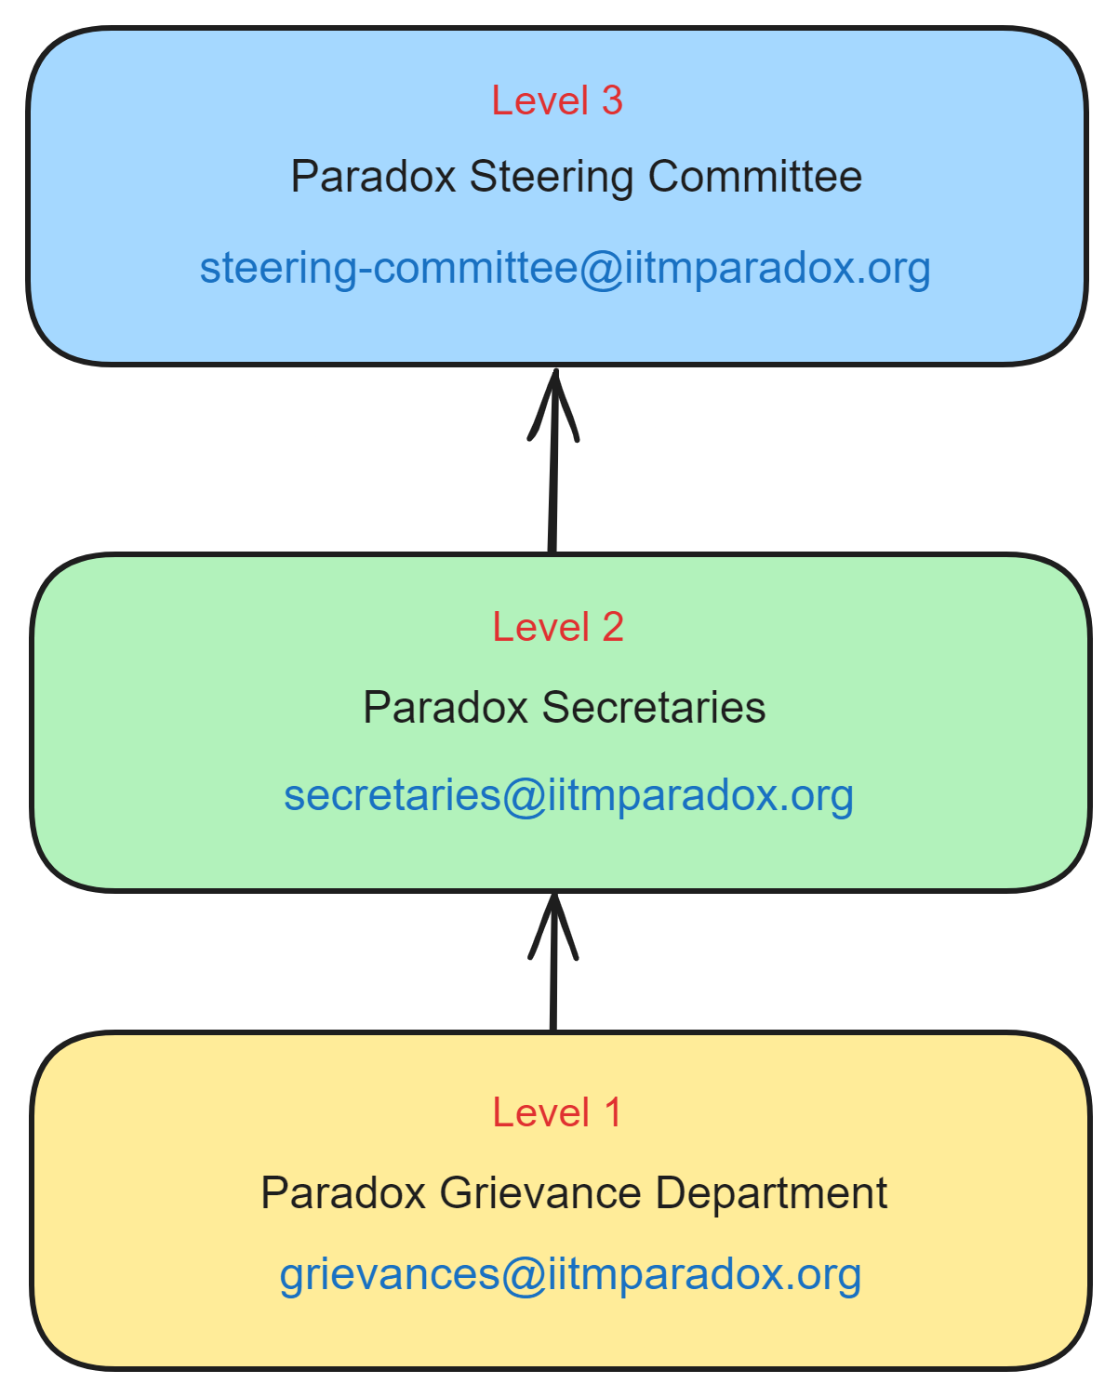

# **Guidelines**

Each department has their specific guidelines as mentioned below:

1. Technicals: [Technical Events](https://docs.google.com/document/d/1Qab5HyVj8y2h10X45FTknb2ZLVyMWtvR4lMPPBekg14/edit?usp=sharing)
2. Culturals: [Cultural Events](https://docs.google.com/document/d/1aykrBPWS6TvEEVgstHi-k1-0TWr3bHghpqkNHeHtsDk/edit?usp=sharing)
3. Sports: [Sports](https://docs.google.com/document/d/1oxYR90h5a_MvbbIzzi9GGn_H8xadcJ277uUp_M67diE/edit?usp=sharing)
4. Sponsorship: [Sponsorship](https://docs.google.com/document/d/17qvDNLi7izVkrH4cc9C8Aw12Di_k81djVKNJ2ryXm8k/edit?usp=sharing)
5. Multimedia Productions: [SOP & Guidelines - Multimedia(PR, Design & Media) | Paradox’24](https://docs.google.com/document/d/1AT0tfeL1svqXrme2G9YOXAYOAMJzDcv_5CDnxeyUTOk/edit)
6. Student Relations: [Student Relations](https://docs.google.com/document/d/1ENNaYDsseA6BRvJl8LEvRwvRH4EP9-38WaDJQSKWIt8/edit?usp=sharing)
7. Safety & Security: TBU
8. WebOps:  [WebOps](https://docs.google.com/document/d/1K12hHFjwZwttKqEhvYJ7H73s-l8ZTVF5BrFnXFn7WSg/edit?usp=sharing)
9. Facilities & Budgeting:
   1. Finance: [Finance Guidelines](https://docs.google.com/document/d/16vvWfcO8y9LsWGhNRjiV8eOAECkai4f9O3qB9RLKY5M/edit?usp=sharing)
   2. FR: [FR Guidelines](https://docs.google.com/document/d/1hm6n5K2xMHF0INI6Yg5kV5x-TG2Xbeyep5SV2TsyItE/edit)
10. Hospitality Relations: [Accommodation and Hospitality](https://docs.google.com/document/d/1NbYysw7t9WOqxAXCOjcvStMNv3prh3ym8ylb7XnH9Zk/edit?usp=sharing)

## **SOP (Standard Operating Procedures)**

Standard Operating Procedures will set up a number of procedures to maximize and streamline the fest's organization. And the SOP of our organization are as follows:

### **All Students**

1. All Paradox guidelines are to be followed: [**Read them here**](https://docs.google.com/document/d/1S0urniWFnA4ex1f71lg7tfB5-KtgSarGiYOe7RuTpVg/edit?usp=sharing)
2. Attending Paradox implies that students consent to being photographed and videotaped during the fest, and permits us to use their images and films on our social media accounts and in Paradox-related documents.

### **Paradox Team**

1. Complete the task given to you on time, and let the person who gave the task know if it will take longer than expected.
2. Make sure your progress is being updated by periodically updating the task tracker. At the end of each fest (Saavan, Margazhi, Paradox), we will evaluate the task tracker, make the proper decision based on the tasks documented, and, if necessary, execute **Level 1 of Repercussions** action.
3. Throughout the communication process, uphold hierarchy. Avoid going around the hierarchy to speak with someone who is higher up directly. This is done to ensure that there is no information flow duplication and to close the communication gap.
4. Without the right authorization from Secretaries, individuals are not permitted to gather student data on behalf of Paradox or disclose our data with any third parties (including but not limited to BS degree Students).
5. Every day, three hours should be devoted to Paradox, which includes communicating with other members of the organization. If the person consistently fails to respond without providing a good reason, they may face impeachment.
6. All official communications are to be done via official email handles or mode of communication decided by Secretaries. Incase of a conflict only written proofs will be considered legit.

### **Event Team**

1. *All event teams will be limited to five members*, and their numbers will only be raised with the Department head's permission if the event calls for a larger team.
2. For any talks pertaining to the fest, the event team will only speak with the department core team and not with the Paradox team, thereby maintaining the hierarchy, in order to preserve the communication chain.
3. If the core team of the event department misbehaves or fails to respond to them promptly, the event team may freely utilize the escalation matrix.
4. There can only be one Event Coordinator and one Event Deputy Coordinator per event team. There may be some exclusions, in which case the event team will need to obtain the Secretaries’ approval.
5. Event teams cannot remove members from the team once they have been officially recorded in the event proposal without the approval of the department head.
6. Event teams cannot make changes to the team once the team details have been recorded by Student Relations, without the approval of the Secretary.
7. Event team will follow the escalation matrix in case of conflicts.

### **Houses and Societies**

1. Paradox will not accept proposals directly from Houses and Societies but individual proposals from the students.
2. A House or a Society may still, however, plan events in Paradox to represent themselves by sending proposals from their House or Society members and mentioning in the proposal that they are acting on behalf of a certain House or Society.
3. The same is also applicable to collaborative events between different Houses and/or Societies.
4. Remember that the current ❝**One Student One POR❞** policy is still in effect and that the POR holders for the House or Society (who will receive a certificate from IITM for their POR) are not permitted to serve as the Event Coordinator or Deputy Event Coordinator.
5. Houses and Societies are not supposed to contact their event participants using their Personal/Society or House Email ID, All correspondence to the participants should be done using the official department email id.
6. The Executives of the House or Society will not be granted any particular treatment during the event's discussion because all events organized by Houses and Societies will be considered equally and without exception.
7. To reiterate the preceding point, the Executives of the House or Society shall not be permitted to attend event team meetings with Paradox unless authorized by the department core.

### **Event Selection:**

1. Every event department shall have their own criteria for event selection. However, Secretaries hold the utmost discretion when it comes to acceptance and rejection of events.
2. Event selection criteria by the event department shall be released every term along with the proposal acceptance form.
3. All proposals, selected or rejected by the core, shall have a valid and detailed reason which will be emailed to the student who submitted the proposal by the respective department core.

## **Impeachment**

Provisions for impeachment of organization’s members will be outlined for the following situations:

1. Undermining the hierarchy.
2. Persistently neglecting to finish the tasks that have been assigned to the individual.
3. The efficacy of the task tracker is not very excellent.
4. Dishonoring the organization.
5. Disregarding the SOP.
6. Inappropriate behavior with other members or creating an uncomfortable working environment for others.
7. Not responding to other members of the organizations repeatedly without a valid reason.
8. Missing 3 or more official emails from the Secretaries and/or Steering Committee.

## **Code of Conduct**

All members of the organizing team, participants, and attendees are expected to adhere to a Code of Conduct promoting a positive and respectful fest environment.

1. [**IITM BS Non Academic Misconducts**](https://docs.google.com/document/d/e/2PACX-1vS3kG688sVzBil9uEFa9mXrnpuMAqE0LU1FpH1-TMDCHZF0XjC1265GmhVePdYvrc0_5qyq8OXwIZUb/pub) is applicable within Paradox.
2. Everything in [**Paradox guidelines**](https://docs.google.com/document/d/1S0urniWFnA4ex1f71lg7tfB5-KtgSarGiYOe7RuTpVg/edit?usp=sharing) are to be followed thoroughly.

# **Repercussions**

Violations of the Code of Conduct may result in appropriate repercussions listed below:

1. **Level 1 (Cores and Above Only):** 
   1. Mild Warning
   2. Severe warning
   3. Removal from the position
2. **Level 2 (Secretaries and Steering Committee Only):**
   1. The entire organizing committee will be sent an official mail regarding the issue and the society/house/club/individual group will be held responsible, and the action taken will be made transparent.
3. **Level 3 (Secretaries and Steering Committee Only):**
   1. Cancellation of event.
   2. Banning the individual/team/house/society from organizing events in Paradox.
   3. Banning the individual(s) from Paradox Accommodations.
   4. Banning the individual/team/house/society from Paradox completely.

# **Charter’s Amendment Process**

* The Paradox Charter mandates that proposed amendments must originate from the Secretaries and be unanimously supported by every member of the Steering Committee and every Secretary before implementation.
* The Steering committee or The Secretaries have the option to reject the proposal together with pertinent remarks and the secretaries, rewrite the complete proposal, and submit it back for a review.
* Until each and every Secretary and Steering Committee member accepts the modification proposal, this process is repeated n times.
* Only the head of student affairs has the authority to overrule the above conditions and accept the charter amendment proposal directly without a full house vote.  
    
  NOTE: Amendment Process for both Department SOP’s and Charter will be the Same.

For the purpose of editing the Charter, upon reaching consensus among all members of the Steering Committee and Secretaries, the initial step shall be to modify the document within the [GitHub repository](https://github.com/iitm-paradox/charter). The merge to the main branch must receive approval from three specified email addresses: secretaries@iitmparadox.org, steering-committee@iitmparadox.org, and kothai@study.iitm.ac.in. Subsequently, changes will be reflected in the Word document. The version of the document maintained in GitHub shall be regarded as the authoritative version, and any modifications made solely to the Word document will not be considered valid.

This Paradox Charter acts as a manual, guaranteeing the fest's seamless and moral operation while upholding its values of excellence, diversity, and inventiveness.